
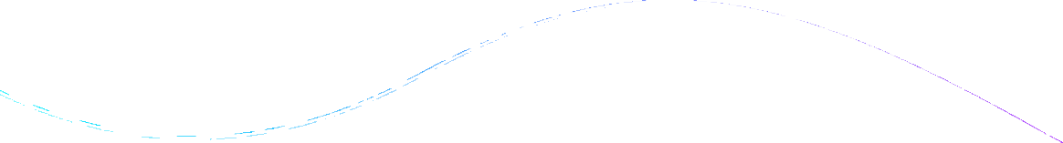
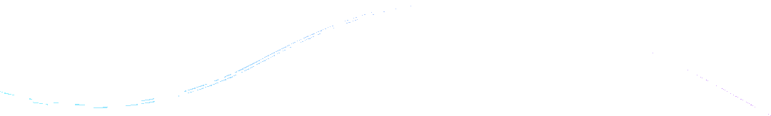
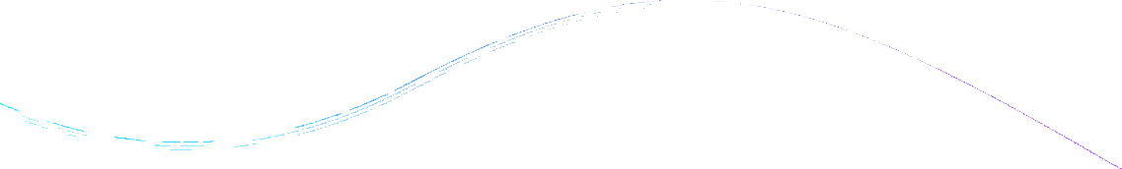
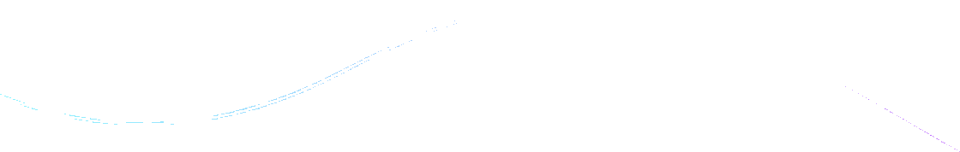
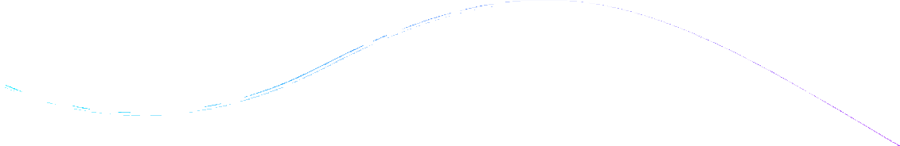
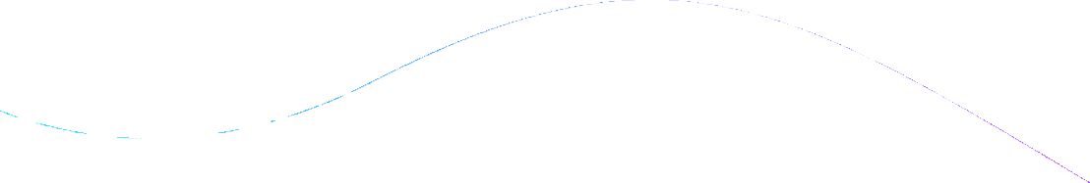

















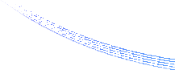
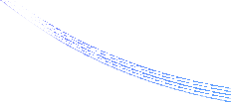
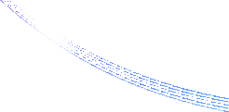
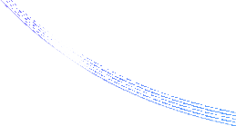
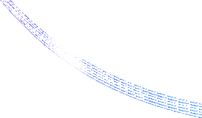
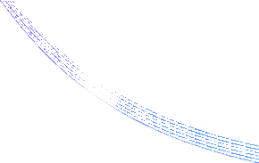
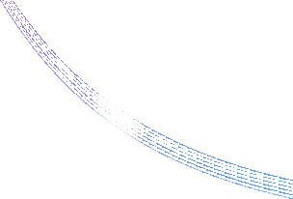
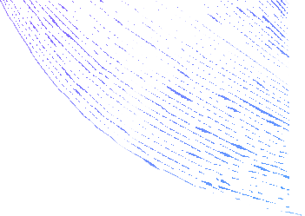

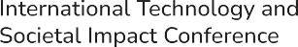



2026

Fri–Sat, February 20–21, 2026

Please tick mark the track you are submitting for

Circularity of Supply Chains in Emerging Economies Enabling Technologies-led Inclusion and Equity
Impact and Externalities of the Triple Bottom Line (TBL) Sustainability Framework
Sustainable Consumer Well-being

TITLE
Keywords: , , , , Introduction





2026

Fri–Sat, February 20–21, 2026

Background literature

Data and methods

2026

Fri–Sat, February 20–21, 2026

Results

Discussion

2026

Fri–Sat, February 20–21, 2026

Conclusion

References

Appendix

