
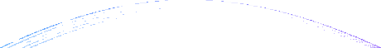

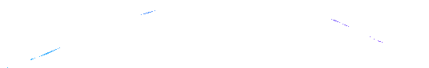


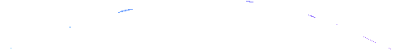





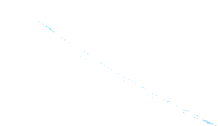

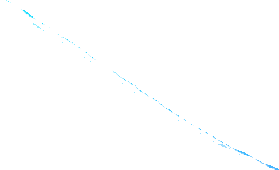




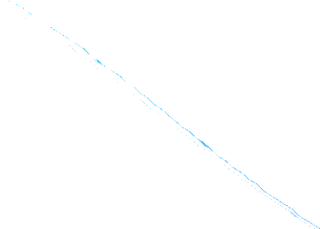

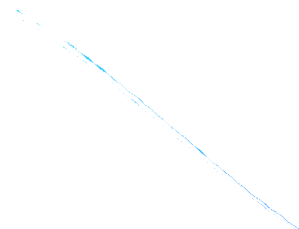






2026

Fri–Sat, February 20–21, 2026

Cover letter

Please provide the following information:

Title:
“(A concise and informative title that reflects the main topic and findings of your paper)”

Author details:
(Include the full names of all authors, their institutional affiliations (with full address), official email IDs, and contact details)

Corresponding Author:
Name: Affiliation: Full Address: Email: Phone:

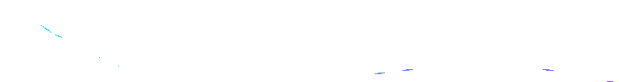





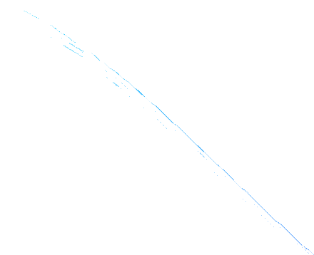
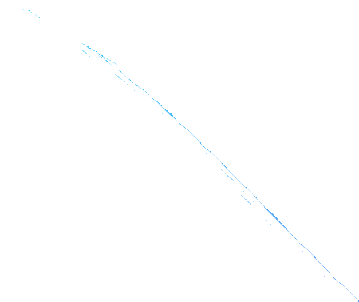

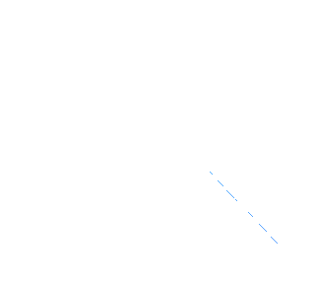





2026

Fri–Sat, February 20–21, 2026

Co-authors:
- Name:
Affiliation:
Email:
- Name:
Affiliation:
Email:

Keywords:
(Include 3–5 relevant keywords that reflect the paper's core theme.)

Author declaration:
The authors affirm that generative AI and AI-assisted technologies (such as ChatGPT, Grammarly, or similar tools) were used only to improve the readability and language of the manuscript. These tools have not been used to perform or replace researchers’ tasks. All substantive content, arguments, and interpretations reflect the authors’ own original work.

Furthermore, the manuscript adheres to academic integrity standards, and the similarity score is below 15%, excluding references, as verified by plagiarism detection software (Turnitin or similar). Additionally, no single source accounts for more than 1% of the overall similarity score.

